C# Tutorial for Intermediate

(https://www.youtube.com/watch?v=ZqDtPFrUonQ)

**What is inside a class?**

* Data (represented by fields)
* Behaviour (represented by methods / functions)

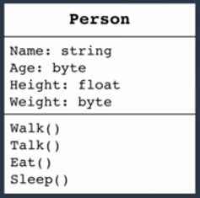 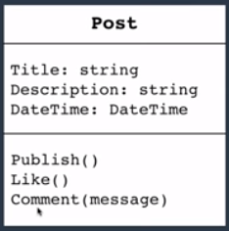 UML

**Object** : an instance of a class

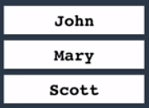

**Declaring Classes Creating an object**

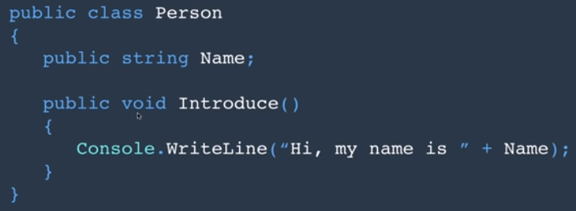 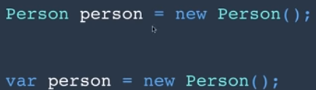

**Class Members**

* Instance: accessible from an object

var person = new Person();

person.Introduce();

* Static: accessible from the class

To represent concepts that are singleton

DateTime.Now

Console.WriteLine();